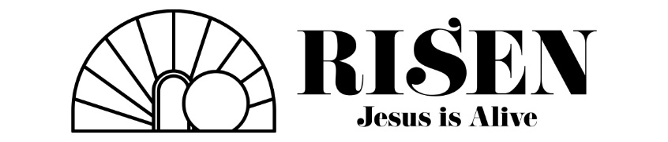

“The Greatest Victory”
(Luke 23:56, Matthew 27:62-28:6)
(Pew Bible Page 884, Pew Bible Page 835)

- Saturday – A Day of Obedience (Luke 23:56)

- The shadow of His death

- The servanthood of His people

- One must wonder at their emotional state…

- Saturday – A Day of Opposition (Matthew 27:62-66)

- Unlikely allies

- Unexpected accuracy

- Unsuccessful attempt

- They had the stone.

- They had the soldiers.

- They had the seal.

- Sunday – A day of Overthrow (Matthew 28:1-6)

- Natural law: The stone was rolled away.

- Earthly power: The soldiers and the seal were shown powerless.

- Spiritual despair: The sacrifice was accepted.

- Legitimate doubt: The Savior was undeniably alive.

And you, who were dead in your trespasses and the uncircumcision of your flesh, God made alive together with Him, having forgiven us all our trespasses, by canceling the record of debt that stood against us with its legal demands. This He set aside, nailing it to the cross. He disarmed the rulers and authorities and put them to open shame, by triumphing over them in Him.
Colossians 2:13-15

